Installation Guide

Oracle

1. Go to <https://www.oracle.com/database/technologies/oracle-database-software-downloads.html> and download Oracle.
2. Choose "Accept License Agreement" and proceed further more to download.
3. When the download completes, unzip the downloaded file and you will get a setup.exe file. Now, right click on setup.exe and "Run as Administrator". An installer window will pop up.

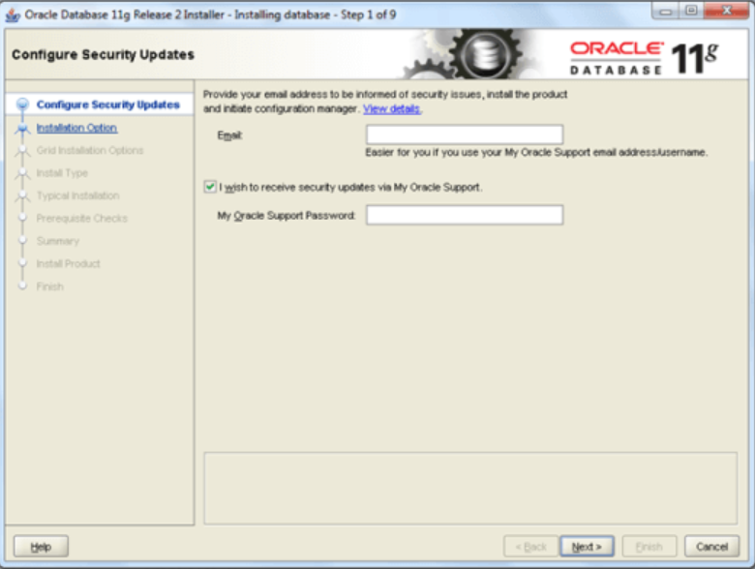

1. You can skip the "configure security updates" option. Now, click on Next.
2. Select the appropriate path to install it and choose your Oracle Standard Password and proceed.
3. Now, Oracle checks up the software requirements and dependencies and it will give the installation summary. Proceed if everything is fine.
4. Now oracle will install the following products in your system.

* Setup files
* Database configuration assistant

1. Always allow these firewalls when it pop ups in your system.
2. Now you can see DBCA(Database configuration assistant) is Installing.

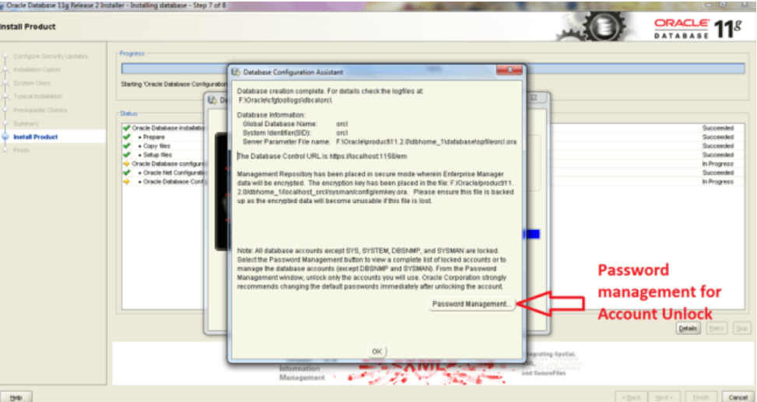

DBCA is a tool who help to create and manage Oracle Databases with GUI.

1. When DBCA installation will complete then a popup window will open.
2. With the help of "Password management" tool you can alter the default passwords for the particular database accounts.
3. Now test your installation done or not.

Open cmd with Run As administrator.

* set oracle_sid=orcl
* Sqlplus / as sysdba

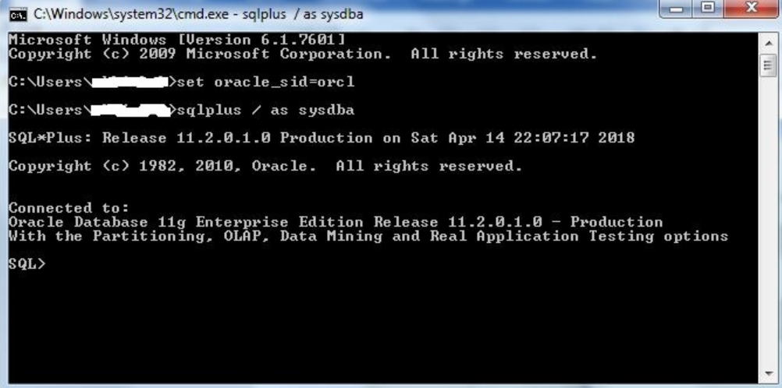

After this command, you will see Oracle Database 11g Enterprise is connected. Now, you are connected to the Oracle Database 11g Enterprise Edition.

**For Oracle Upgrade**

For upgrading the latest version of the oracle 20.1, click the link below and follow the steps

<https://www.oracle.com/database/technologies/upgrade-apex-within-database-11g-xe.html>

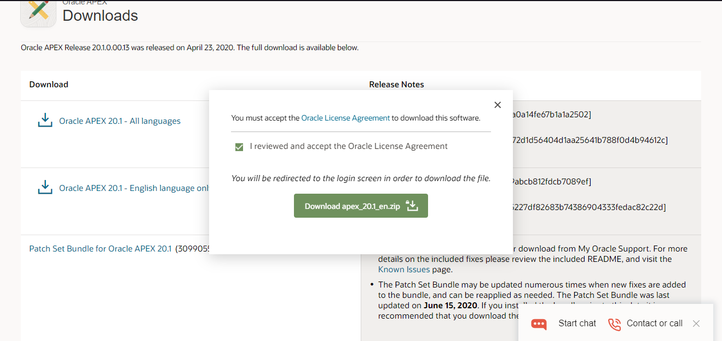

Following above steps and implementing the codes in command prompt

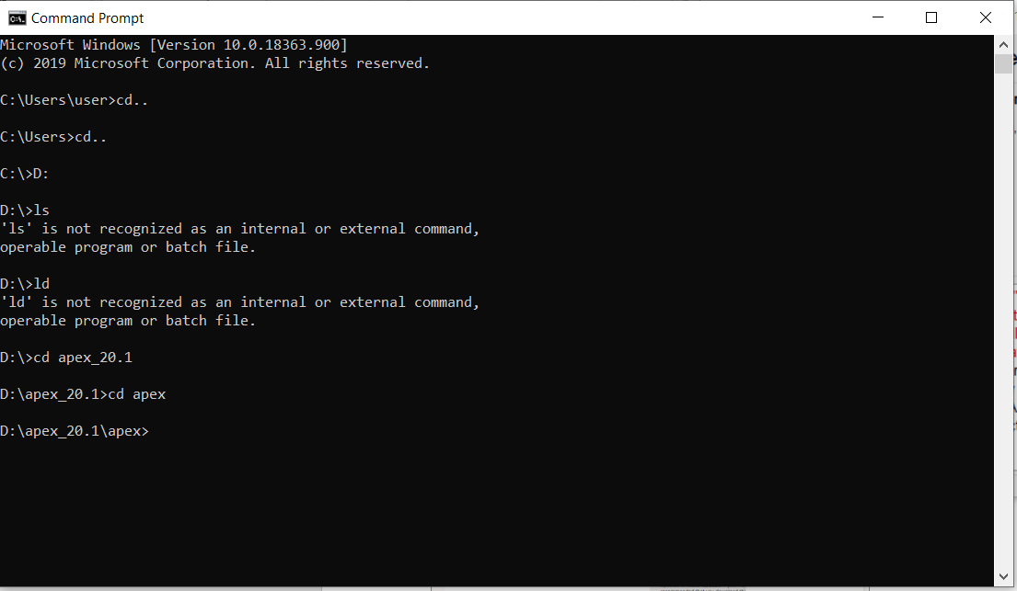

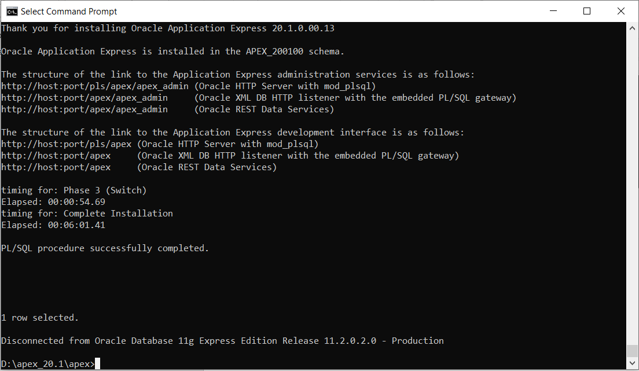

**Upgrade version of Oracle**

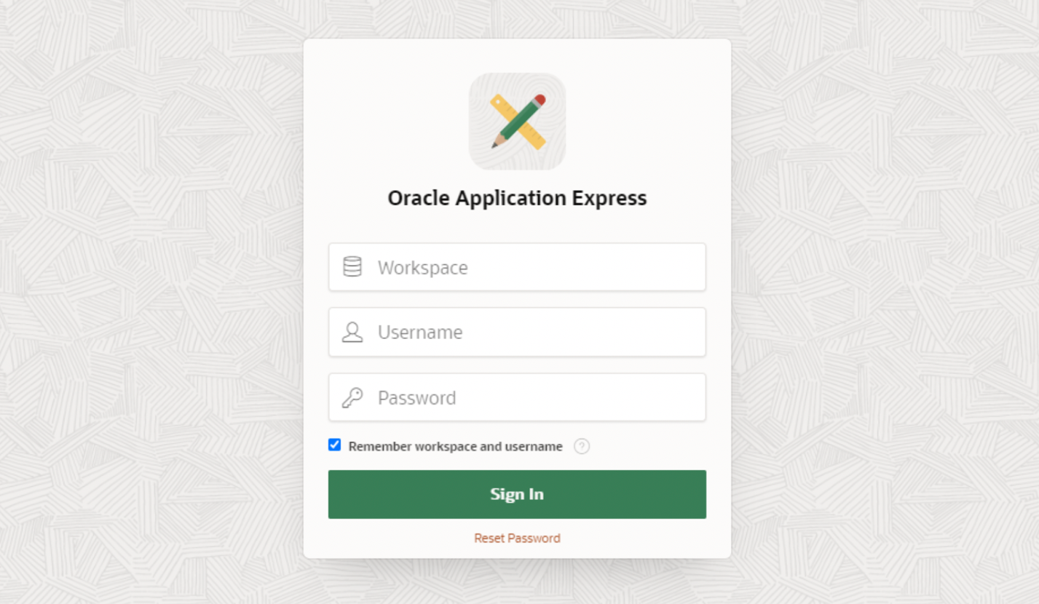

**Importing SQL for the user guidelines**

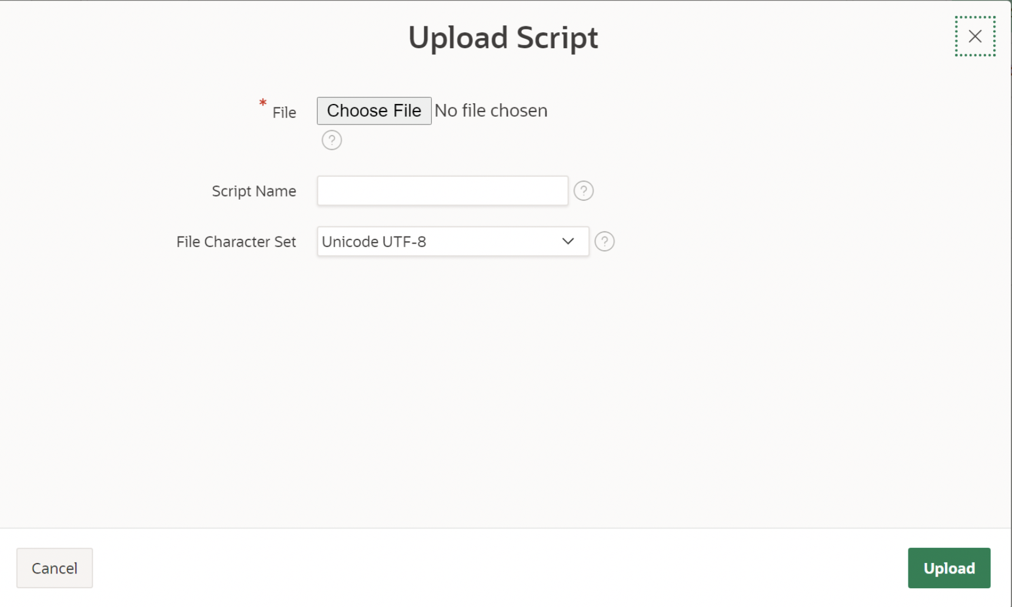

From here, we import SQL files to oracle.